Binomial Distribution:

In probability theory and statistics, the binomial distribution with parameters n and p is the discrete probability distribution of the number of successes in a sequence of n independent experiments, each asking a yes-no question, and each with its own Boolean-valued outcome: success (with probability p) or failure (with probability q=1-p). A single success/failure experiment is also called a Bernoulli trial / Bernoulli experiment, and a sequence of events is called a Bernoulli process. For single trial, i.e, n = 1, the binomial distribution is a Bernoulli distribution. The binomial distribution is the basis for the popular binomial test of statistical significance.

We will use probability mass function as we are working with discrete random variables.

Example: Tossing a coin 10 times, n = 10

Notation for Binomial distribution: B(n,p)

Parameters:

n $∈$ {0,1,2,3,…} = no. of experiments

p $∈\left[0,1\right]$ = success probability for each trial

q = 1-p

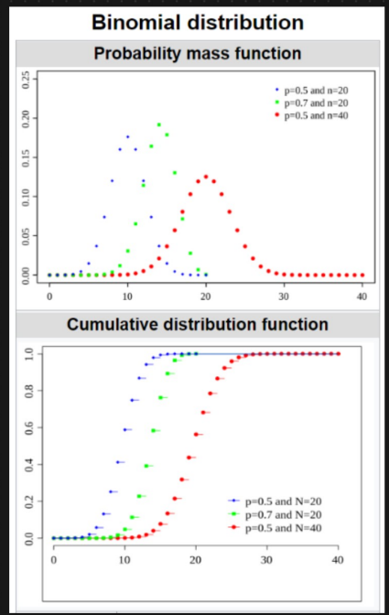Support parameter:

K $∈$ {0,1,2,3,..,n} = shows number of successes

Probability Mass Function:

Pr(K,n,p) = ${n_{c}}_{k}*p^{k}{(1-p)}^{n-k}$

For K = 0,1,2,3,..,n where

${n_{c}}_{k}=\frac{n!}{K!\left(n-K\right)!}$ = Binomial coefficient

Mean = n \* p

Variance = n \* p \* q

Standard deviation = $\sqrt{npq}$

Example:

Coin Flip

No of trials (n) = 5

Probability of success of a fair coin(p) = 0.5

No. of success (k) = 0 to 5

What is the probability of getting exactly 3 heads in 5 flips?

n = 5, K = 3

Pr(X=3) = ${5_{c}}_{3}$ ${(0.5)}^{3}{(1-0.5)}^{2}$ = 0.3125

Example:  
Quality Control

Scenario: Inspecting 10 items in a factory where each item has a 10% chance of being defective.

Number of trials (n) = 10

Probability of success (p) = 0.1 (defective item)

No. of success (k) = 0 to 10

Question: What is the probability of exactly 2 defective items in a sample of 10?

n = 10, k = 2

Pr(X=2) = ${{10}_{c}}_{2}$ ${(0.1)}^{2}{(1-0.1)}^{8}$ = 0.1937